**Worksheet 4: Writing algorithms**

**Task 1**

Here is some sample pseudocode. Use this as a guide to write pseudocode algorithms for the descriptions in the questions below.

**input PIN**

**if *correct PIN entered* then**

**unlock phone**

**else**

**print "Try again"**

**endif**

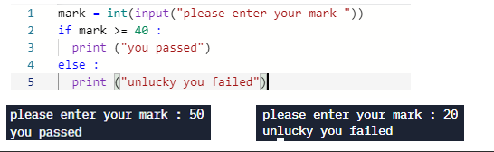1. Read in a student’s mark and print ‘pass’ or ‘fail’ depending on their mark. The pass mark is 40 or more.

**pseudocode**

Mark Input(“Please enter a mark”)

IF mark >= 40 THEN

OUPUT(“You passed”)

Else:

OUTPUT (“Unlucky you failed”)

Endif

2. To print the correct hat size based on the circumference of your head:

* Less than 57cm = Small
* Greater than 60cm = Large
* Anything in between = Medium

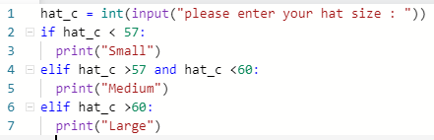

**pseudocode**

Hat_c = Input(“Please enter a hat size ”)

IF Hat_c < 57 THEN

OUTPUT (“Small”)

ELIF Hat_c > 57 AND Hat_c < 60 THEN

OUTPUT(“Medium”)

ELIF Hat_c > 60 THEN

OUTPUT (“Large”)

Endif

3. For a program that will:

* Read in the price of an item and the quantity purchased.
* Calculate the total spend.
* If the total spend is £50 or more, the customer will be given a discount of 10%. Calculate the discount if due.
* If applicable, display a message saying they qualify for a discount and the discount amount.
* Output the amount to pay, (deduct any discount due if applicable to the total spend)

Here is an example where discount is applicable

Item Price: £6, quantity purchased: 10

Total Spend : £60

Discount : £6 (10% of £60)

Amount to pay : £54

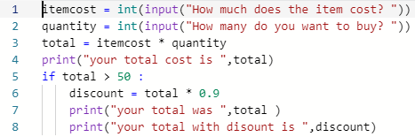

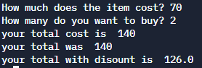

**PSUEDOCODE**

Itemcost = input(“How much does the item cost?”)

Quantity = input(“How many do you want to buy?”)

Total -> Itemcost * Quantity

OUTPUT (“You total cost is” + total)

IF Total > 50 THEN

Discount = Total * 0.9

OUTPUT (“Your total was” + total)

OUTPUT (“Your total with discount is” + discount)

Endif